

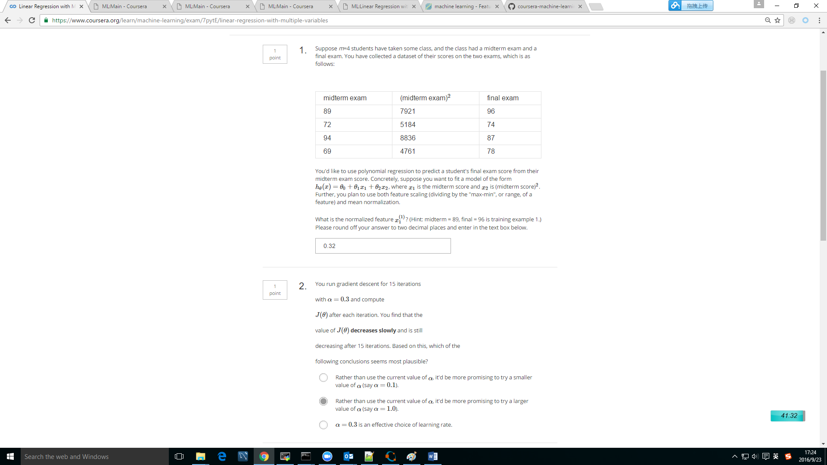

Result

= (xi - average)/(max-min)

=(89-81)/(94-69)=0.32



J decrease slow:　learning rate too small

J increase: learning rate too large

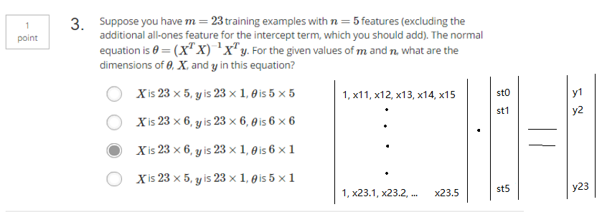

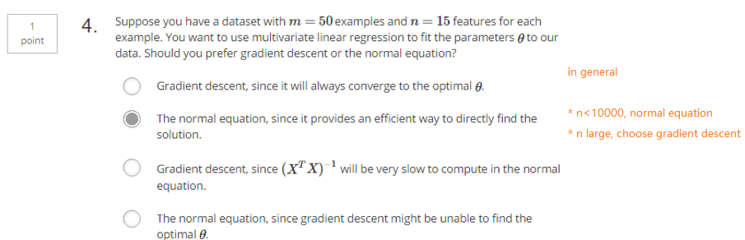

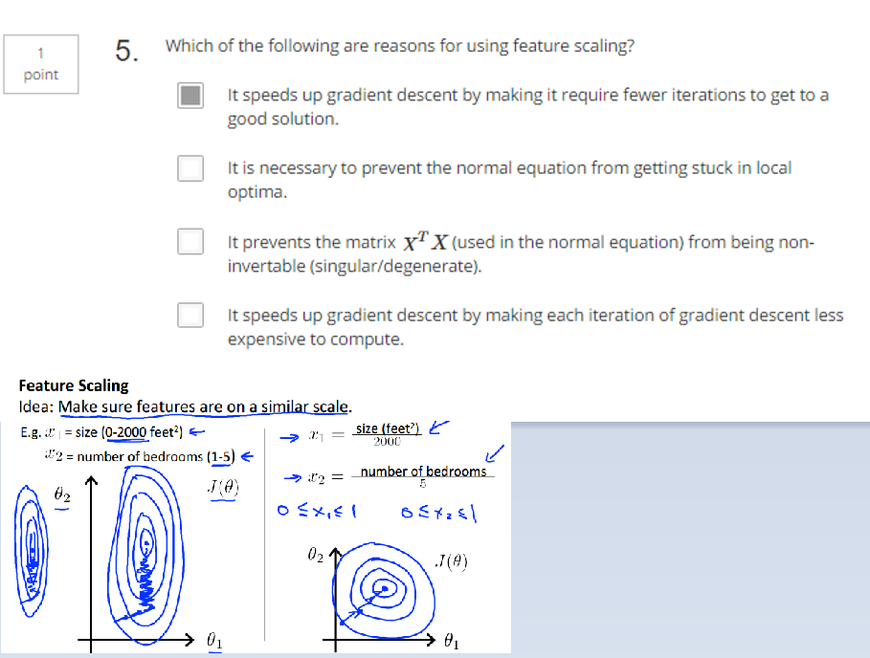

让轮廓图不出现扁平的情况，迭代过程尽快收敛